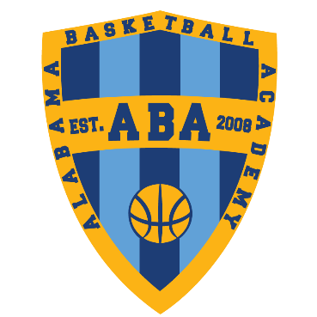

ABA FALL LEAGUE RULES

Games are 2 – 18 minute halves with a running clock. The clock will stop the last minute of the game.
Halftime is a long – 1-1:30 timeout.
Each player has will be assigned a number for the Substitution Rotation. All games will be governed by the Substitution pattern. Clock will stop every 4:30 minutes for quick subs.
The last 2 minutes of each game is open to FREE Substitution on Dead Balls.
Team Fouls are kept – not Individual Fouls. However, if a player continues to foul in a manner not in the spirit of the rules of basketball – he/she will be disqualified from the game.
1 & 1 Free Throws will be attempted on the 7th foul of the half, 2 Free Throws on the 10th foul +.
Before Round 2 - Each player will receive an ABA Fall League dri-Fit shirt (to keep). They need to wear it each week to their games. One team will play in the dri-Fit shirt and one team will wear an ABA Scrimmage Vest to be turned in after the game.
Please notify us if you will not be able to make a game – so we can find a substitute player.
We will keep up with W/L record of each team. And seed each team for the playoff week.
Make sure to arrive 20 minutes prior to game time – there will be a very short warm-up prior to tip.
Overtime is SUDDEN DEATH – 1st team to score.
Each player from the winner of each Division will receive a CHAMPIONS T-shirt.
There is NO admission charge for the regular season games.
There is a $5 charge for adults for all playoff games OR you can make a donation of 2 canned items per adult – this will be given to the Inner City Church Pantry.

>>FOR THE MOST UP TO DATE INFORMATION – FOLLOW US ON INSTAGRAM + TWITTER (@alabballacad).
Questions – info@ababball.com

